MEDICAL DIAGNOSTIC TEST CENTER PORTAL
A ServiceNow-Based Application for Digitizing Diagnostic Center Operations

A PROJECT REPORT

Submitted By:Swathi S
a2354@krce.ac.in
[KRCE/CSE(AIML)]
04/09/26

Medical Diagnostic Test Center Portal
ServiceNow Project Documentation
1. Introduction
The Medical Diagnostic Test Center Portal is a ServiceNow-based application designed to digitize and automate the diagnostic test appointment management process.
The system provides a centralized platform where patients can browse diagnostic tests, check appointment availability, book appointments, make payments, track appointment status, and securely access diagnostic reports.
The system also supports receptionists, laboratory technicians, and administrators by automating appointment processing, report management, notifications, and access control.
The application is developed using ServiceNow features such as Service Portal, Custom Tables, Client Scripts, Business Rules, Flow Designer, Notifications, ACLs, Reports,
and Dashboards.
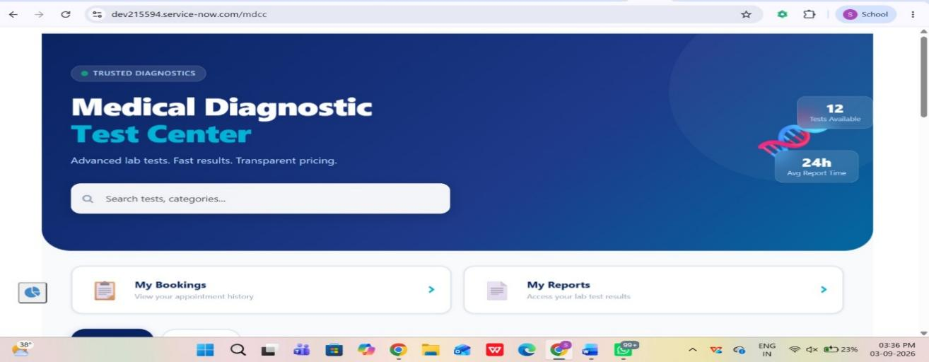
2. Problem Statement
Traditional diagnostic center operations often involve manual appointment booking, phone-based communication, paper-based reports, and limited appointment tracking.
The major problems include:
- Manual appointment scheduling
- Difficulty checking available time slots
- Duplicate appointment bookings
- Delays in report delivery
- Lack of centralized appointment tracking
- Manual notification processes
- Unauthorized access to medical information
- Difficulty managing cancellations and refunds
3. Objectives
The main objectives of the system are:
- To provide online diagnostic test booking.
- To display available appointment slots dynamically.
- To prevent duplicate appointment bookings.
- To automate appointment processing using Flow Designer.
- To provide secure diagnostic report management.
- To automate email notifications.
- To implement role-based access control.
- To provide appointment status tracking.
- To reduce manual administrative work.
- To provide a scalable platform for diagnostic center operations.
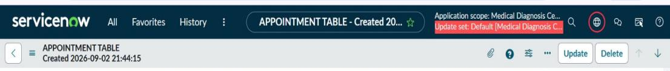

4. System Users
The system supports four major user roles.
User | Responsibilities
Patient | Select tests, book appointments, make payments, view appointments and reports
Receptionist | Manage appointments, approvals, cancellations and patient requests
Lab Technician | View assigned appointments, update sample status and upload reports
Administrator | Manage system configuration, users, security, tables, workflows and reports

5. Technology Stack
Component | Technology
Platform | ServiceNow
Frontend | Service Portal
UI | HTML, CSS, AngularJS
Backend | ServiceNow Server-side scripting
Database | ServiceNow Tables
Automation | Flow Designer
Business Logic | Business Rules / Scripts
Client-side Validation | Client Scripts
Security | ACLs and Roles
Notifications | ServiceNow Email Notifications
Reporting | Reports & Dashboards
Deployment | Update Sets

6. Prerequisites
Before implementing the application, the following requirements must be available.
ServiceNow Requirements
- Active ServiceNow instance
- Service Portal enabled
- Studio / Scoped Application Development access
- Administrator access
- Flow Designer access
- ACL configuration access
- Business Rule configuration access
- Email Notification access
- Reports and Dashboards access
Required Roles
The administrator should have the required permissions to create and configure:
- Tables
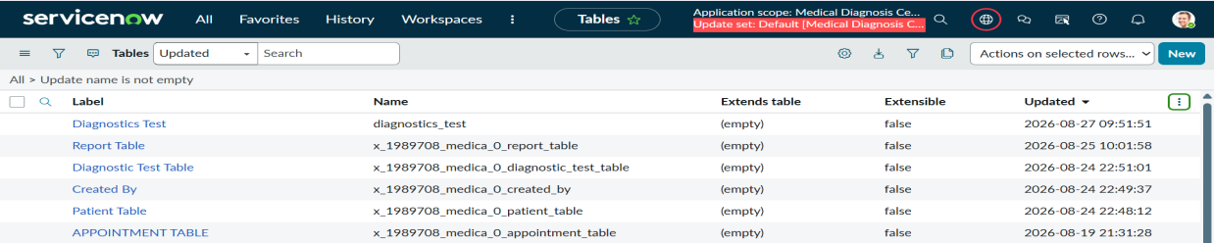
- Fields
- Forms
- Service Portal pages
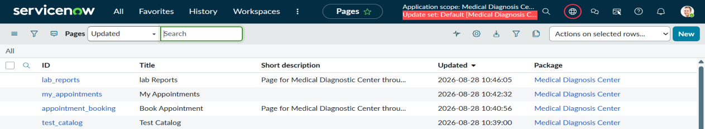
- Widgets
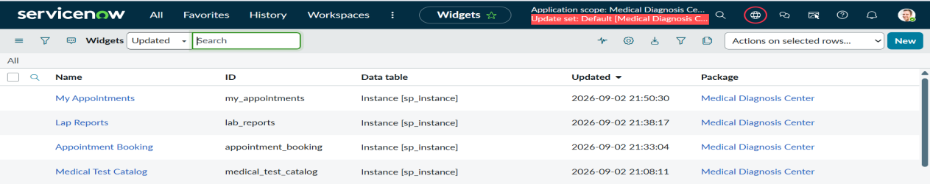
- Client Scripts
- Business Rules
- Flows
- Notifications
- ACLs
- Reports
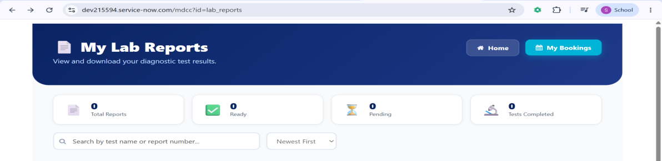

7. System Architecture
The application follows a layered architecture.
User Layer
Patients, Receptionists, Lab Technicians and Administrators interact with the application.
↓
Service Portal Layer
The Service Portal provides:
- Homepage
- Test catalog
- Appointment booking
- Appointment tracking
- Report access
- Payment interface
↓
Application Layer
ServiceNow application logic handles:
- Validation
- Pricing
- Slot management
- Appointment processing
- Notifications
- Report processing
↓
Automation Layer
Flow Designer and Business Rules automate:
- Appointment processing
- Approvals
- Payment confirmation
- Status updates
- Notifications
- Cancellation processing
↓
Data Layer
Custom ServiceNow tables store:
- Patient information
- Diagnostic tests
- Appointments
- Reports
- Payments

8. Custom Table Configuration
The application uses multiple custom tables to maintain structured information.
8.1 Patient Table
The Patient table stores patient information.
Important fields
- Patient ID
- Patient Name
- Date of Birth
- Gender
- Contact Number
- Email
- Address
A unique auto-generated Patient ID can be configured using the prefix:
PAT

8.2 Diagnostic Test Catalog
This table stores the diagnostic tests offered by the center.
Fields
- Test ID
- Test Name
- Test Description
- Test Category
- Price
- Duration
- Availability
- Status
Example:
Test | Price | Status
Blood Test | ₹500 | Active
X-Ray | ₹800 | Active
MRI | ₹3000 | Active

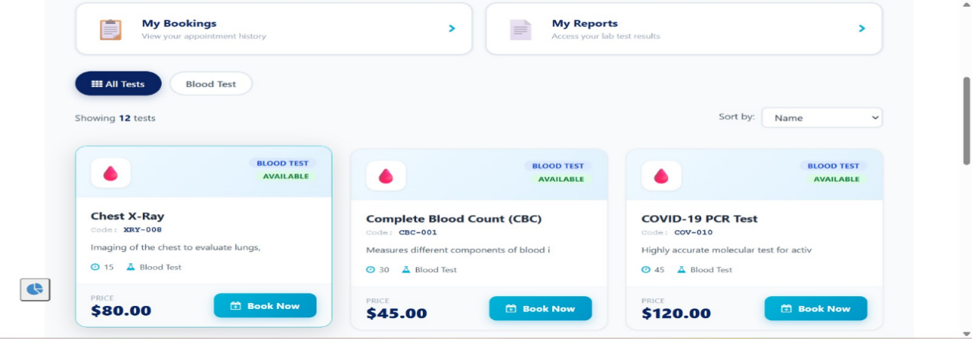

8.3 Appointment Details
This table manages patient appointments.
Fields
- Appointment Number
- Patient
- Diagnostic Test
- Appointment Date
- Appointment Time
- Status
- Price
- Payment Status
- Assigned Technician
- Created Date
Appointment numbers can be automatically generated using:
APPT

8.4 Report Records
The Report table manages diagnostic reports.
Fields
- Report Number
- Appointment
- Patient
- Test
- Report File
- Uploaded By
- Upload Date
- Report Status
Report numbers can use the prefix:
REP
8.5 Payment Table
The Payment table stores payment-related information.
Fields
- Payment ID
- Appointment
- Patient
- Amount
- Payment Status
- Payment Date
- Transaction ID
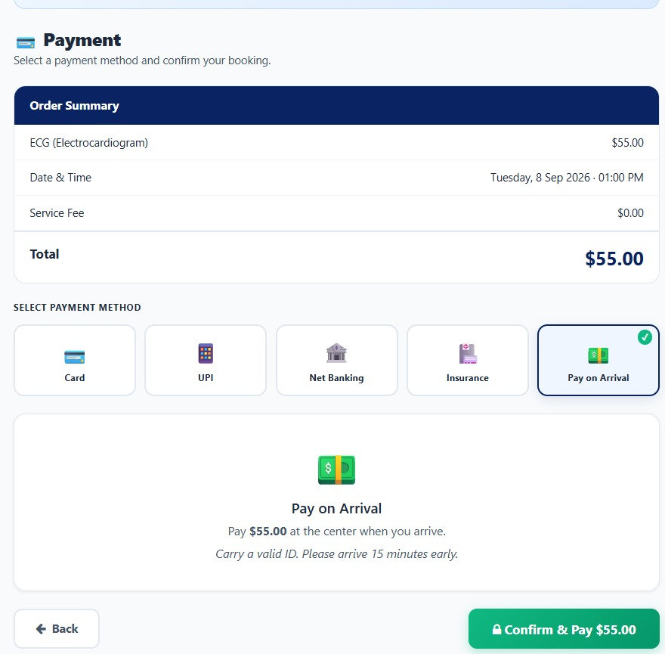

9. Reference Relationships
Relationships between tables are established using reference fields.
Patient
↓
Appointment
- Diagnostic Test
- Payment
- Report

10. Service Portal Configuration
A dedicated Service Portal is created for the Diagnostic Test Center.
Portal Configuration
The following components are configured:
- Portal title
- Logo
- Theme
- Homepage
- Navigation menu
- Footer
- Search functionality
Custom Pages
The portal contains pages such as:
- Test Selection
- Appointment Booking
- My Appointments
- Report Download
- Payment
- Booking Confirmation

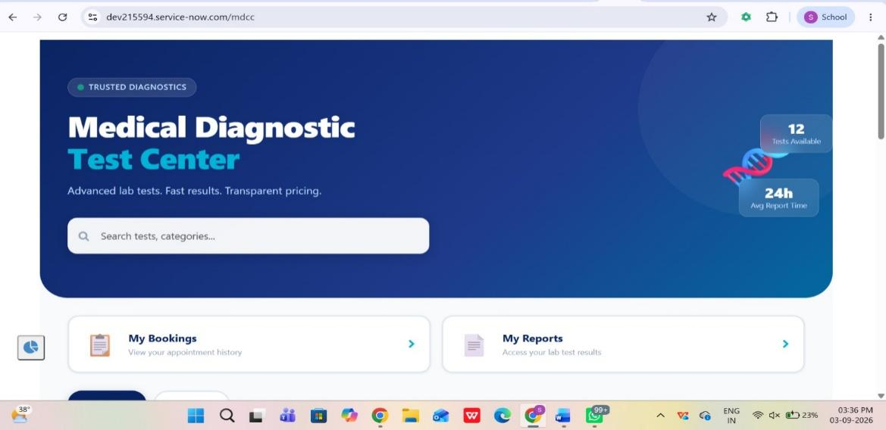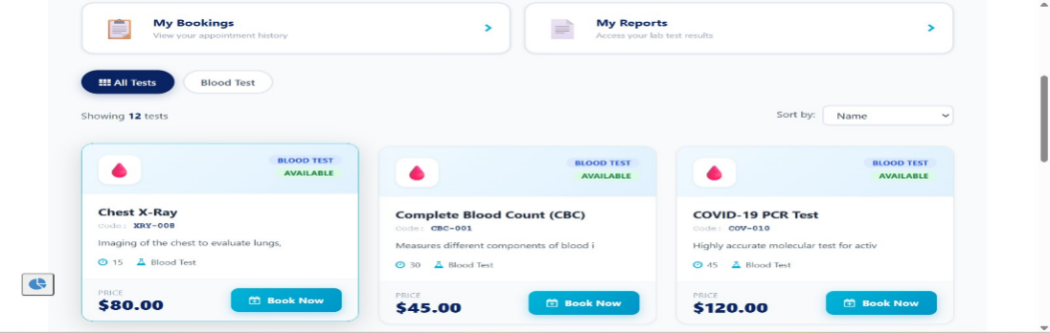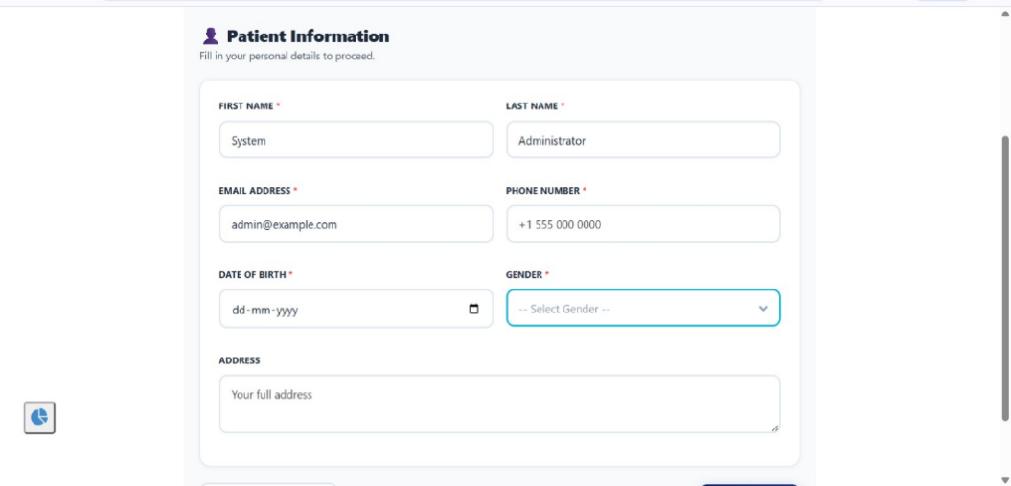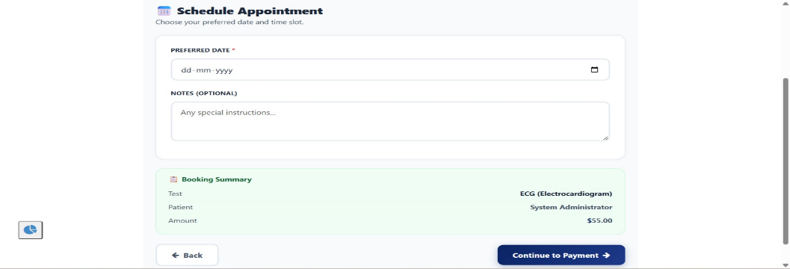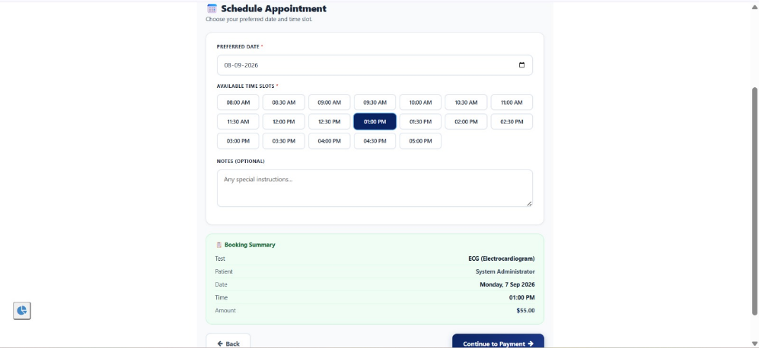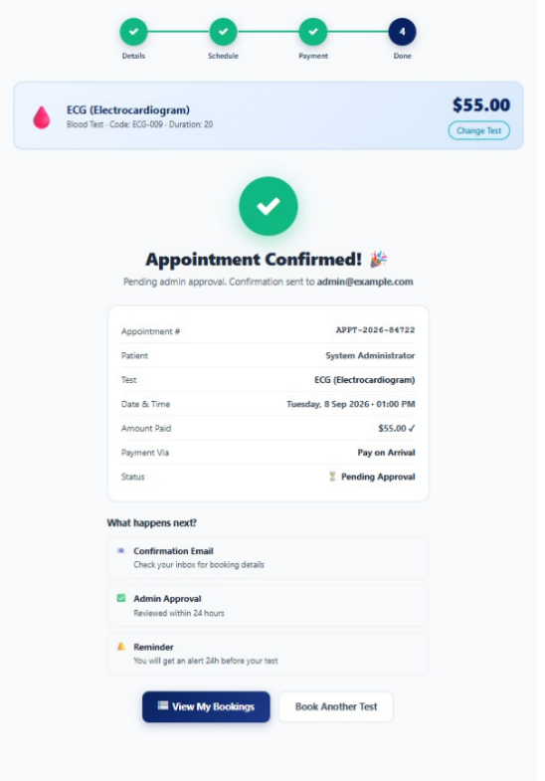
11. Custom Widget Development
Custom Service Portal widgets are developed to provide an interactive user interface.
Technologies Used
- HTML
- CSS
- AngularJS
- Server Script
- Client Controller
Major Widget Functions
The widgets provide:
- Diagnostic test display
- Dynamic slot availability
- Appointment booking
- Price calculation
- Booking confirmation
- Appointment tracking
- Report visibility
- Report download
The widgets are tested using Service Portal Preview before deployment.
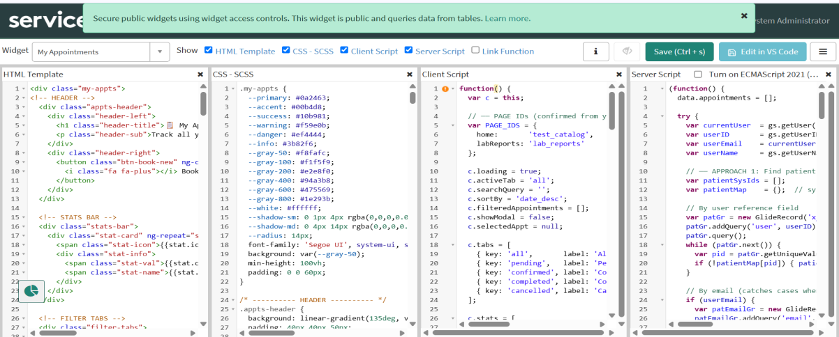

12. Appointment Booking Process
The appointment booking process follows these steps:
Patient Login
↓
Select Diagnostic Test
↓
Select Date
↓
Display Available Slots
↓
Select Time Slot
↓
Validate Appointment
↓
Calculate Price
↓
Create Appointment
↓
Payment
↓
Confirmation

Validation
The system verifies:
- Mandatory fields
- Valid appointment date
- Available slot
- Duplicate booking
- Test availability
- Patient information
If validation fails, the user receives an appropriate error message.

13. GlideRecord Implementation
GlideRecord is used for server-side database operations.
It can be used to:
- Retrieve patient records
- Check existing appointments
- Create new appointments
- Update appointment status
- Retrieve reports
- Validate slot availability
For example, before creating an appointment, the system can query existing appointment records to determine whether the selected date and time slot is already occupied.

14. Flow Designer Automation
Flow Designer is used to automate the application workflow.
Main Flows
Flow 1 – Appointment Booking
Trigger:
New appointment created.
Actions:
- Validate appointment
- Process booking
- Update status
- Send confirmation notification

Flow 2 – Approval
Trigger:
Appointment requires approval.
Actions:
- Send approval request
- Wait for approval
- Update appointment status
- Notify patient

Flow 3 – Report Availability
Trigger:
Diagnostic report uploaded.
Actions:
- Update report status
- Update appointment status
- Send notification to patient

Flow 4 – Cancellation and Refund
Trigger:
Appointment cancelled.
Actions:
- Update appointment status
- Process refund logic
- Update payment status
- Send cancellation confirmation

15. Appointment Status Lifecycle
The appointment follows a defined lifecycle:
Requested
↓
Approved
↓
Confirmed
↓
Sample Collected
↓
Report Available
↓
Completed
An appointment may also move to:
Cancelled
depending on the cancellation process.
This lifecycle allows users and administrators to track the current state of every appointment.
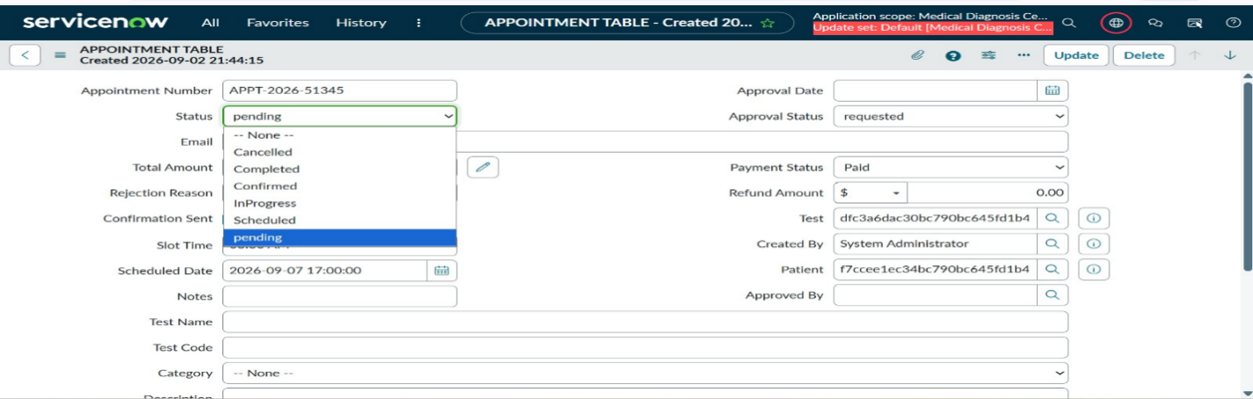

16. Notifications
Automated email notifications are configured for important events.
Notifications include:
- Appointment booking confirmation
- Payment confirmation
- Approval notification
- Rejection notification
- Appointment reminder
- Report availability
- Cancellation confirmation
- Refund confirmation
Dynamic information can be included in emails, such as:
- Patient name
- Test name
- Appointment number
- Appointment date
- Appointment time
- Payment amount
- Report information

17. Scheduled Jobs
Scheduled jobs are used for time-based operations.
Examples
Appointment Reminder
Automatically identifies upcoming appointments and sends reminder notifications.
Missed Appointment Update
Identifies appointments that have passed without completion and updates their status.

Expired Booking Cleanup
Identifies expired pending bookings and releases the associated slots.
Scheduled jobs improve automation and reduce manual administrative work.

18. Security & ACL Configuration
Since the system handles sensitive medical information, security is a major component.
Access Control Lists are configured at table and field levels.
Patient Access
Patients can:
- View their own appointments
- View their own reports
- Create appointments
Patients cannot:
- View another patient's information
- Modify administrative records
- Access another patient's report
Lab Technician Access
Lab Technicians can:
- View assigned appointments
- Update sample collection status
- Upload reports
Administrator Access
Administrators can:
- Manage patients
- Manage appointments
- Manage diagnostic tests
- Manage reports
- Configure workflows
- Manage security

19. Security Testing
Security is validated using:
Impersonation
The administrator can impersonate different users to verify their access permissions.
Debug Security Rules
ServiceNow security debugging can be used to identify why a user is allowed or denied access.
Role-Based Testing
Separate test users are created for:
- Patient
- Receptionist
- Lab Technician
- Administrator
This ensures that each role receives only the required permissions.

20. Error Handling
The application handles multiple edge cases.
Scenario 1 – Occupied Slot
If a patient attempts to book an already occupied slot:
Result: Booking is rejected.
Scenario 2 – Missing Information
If mandatory fields are empty:
Result: Validation message is displayed.
Scenario 3 – Duplicate Booking
If the same patient attempts to create a duplicate booking:
Result: System prevents the duplicate record.
Scenario 4 – Unauthorized Report Access
If a patient attempts to access another patient's report:
Result: ACL prevents access.
Scenario 5 – Appointment Cancellation
When an appointment is cancelled:
- Appointment status is updated.
- Payment/refund status is processed.
- Notification is sent.

21. Testing & Validation
The application is tested using multiple test scenarios.
Test Case | Expected Result
Select diagnostic test | Test selected successfully
Select available slot | Slot selected
Select occupied slot | Booking prevented
Submit valid appointment | Appointment created
Missing mandatory field | Validation error
Approve appointment | Status updated
Reject appointment | Status updated
Upload report | Report stored
Download report | Authorized patient can access
Unauthorized report access | Access denied
Cancel appointment | Status changed to Cancelled
Notification trigger | Email generated

22. Reports & Dashboards
Reports and dashboards can be configured for administrators.
Possible reports include:
- Total appointments
- Completed appointments
- Cancelled appointments
- Pending appointments
- Test-wise bookings
- Revenue/payment summary
- Report completion status
Dashboards provide administrators with a centralized view of system activity.

23. Deployment
After development and testing, configurations are moved between ServiceNow instances using Update Sets.
Deployment Process
Development
↓
Configuration
↓
Unit Testing
↓
Integration Testing
↓
Update Set
↓
Test Instance
↓
User Acceptance Testing
↓
Production
↓
Smoke Testing

24. Final Outcome
The Medical Diagnostic Test Center Portal successfully provides an automated platform for managing diagnostic center operations.
The system:
- Reduces manual appointment processing
- Prevents duplicate bookings
- Automates workflows
- Provides real-time appointment tracking
- Enables secure report management
- Automates notifications
- Implements role-based security
- Improves administrative efficiency
25. Future Enhancements
- Online Payment Gateway
- SMS Notifications
- Mobile Application
- Hospital Integration
- Advanced Analytics
- AI-Assisted Diagnosis

26. Conclusion
The Medical Diagnostic Test Center Portal demonstrates how ServiceNow can be used to automate a complete healthcare diagnostic workflow.
By combining Service Portal, Custom Tables, Client Scripts, GlideRecord, Flow Designer, Notifications, Scheduled Jobs, ACLs, Reports, and Dashboards, the system provides a centralized solution for appointment booking, processing, report management, and status tracking.The implementation improves operational efficiency while maintaining controlled access to sensitive information.
Overall, the project provides a secure, automated, scalable, and user-friendly platform for managing diagnostic test center operations.

